Name _____________________________  Date ___________________ Blk: _____ | 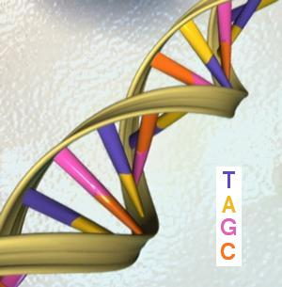

Biology Key Terms
These are the vocabulary words that you should know for your final exam.

Chapter 4 | Chapter 5 | Chapter 6
chromosome  DNA  endoplasmic reticulum  enzyme  gene  gene mutation  gene therapy  golgi body  hormone  mitochondrion  mutagen  negative mutation  neutral mutation  nucleolus  nucleus  positive mutation  protein  ribosome | asexual reproduction  binary fission  budding  cancer  cell cycle  clone  cytokinesis  fragmentation  interphase  mitosis  DNA replication  spindle fibres  spore formation  stem cell  vegetative reproduction | diploid number  egg  embryo  external fertilization  fertilization  gametes  genetic diversity  haploid number  homologous chromosomes  internal fertilization  meiosis  sperm  sexual reproduction  zygote

Biology Key Concepts
These are the main ideas from Biology. Fill-in-the-blanks to complete.

Chapter 4: The nucleus
- Chromosomes found within the ____________________ contain the genes that store the information to make ______________________. Humans have ______ pairs of chromosomes for a total of ________ chromosomes. (4.1)
- Proteins control the activities of cells. (4.1)
- _________ is the molecule that carries genetic information (4.1)
- __________________________ make proteins, which can be used in the cell or sent out of the cell as ______________________ (chemical messengers)or _________________________ (speed up chemical reactions) (4.1)
- A gene _____________________ is a change in the order of the A, G, C, and T bases. (4.2)
- Gene mutations, caused by ___________________________, can have a ________________, ____________________, or _______________________ effect on the individual. (4.2)
- Gene _________________________ attempts to correct gene mutations. (4.2)

Chapter 5: Mitosis and asexual reproduction
- There are three stages to the cell cycle: ________________________, ____________________ and _________________________. (5.1)
- There are ________ phases to mitosis:
__________________ --> ___________________ --> __________________ --> ___________________
- Mitosis creates cells that are _________________ to each other and the mother cell. (5.1)
- ____________________________ proteins instruct the nucleus whether to proceed through the cell cycle. And an error in one of these proteins can cause diseases such as ____________________, which is the result of uncontrolled cell division. (5.1)
- Asexual reproduction requires only ________ parent, and the resulting offspring are genetically ____________________ to the parent. (5.2)
- Types of asexual reproduction include: (5.2)
____________________________ ____________________________
____________________________ ____________________________
____________________________
- Human-assisted plant and animal cloning methods can be used to save the genetic information of endangered species or to produce an organism with a desired trait. (5.2)

Chapter 6: Meiosis and sexual reproduction
- Meiosis produces specialized sex cells called ____________________ that have ___________ the number of chromosomes as body cells.
--> human sperm has ______ chromosomes and eggs have ______ chromosomes (6.1)
- The process of meiosis creates __________________________ in organisms because genetic information is shuffled during meiosis I. (6.1)
- _____________________________ mutations can occur during meiosis and can cause genetic disorders. (6.1)
- The three stages of sexual reproduction are:
___________________ --> ________________________ --> _______________________ (6.2)
- For sexually reproducing plants and animals, there are two ways for a sperm cell and an egg cell to meet—through either ______________________ or _______________________ fertilization. (6.2)
- There are advantages and disadvantage for sexual and asexual reproduction (6.2)
- The early development of an organism takes place during a stage called ________________________ development. (6.2)
- Assisted reproductive technologies enable __________________ couples to have children. (6.3)

Matching
1. | ______ | golgi body | A. | sperm & egg
2. | ______ | nucleus | B. | transportation network of a cell
3. | ______ | mitochondrion | C. | stage of development after the zygote phase
4. | ______ | nucleolus | D. | the control center of the cell
5. | ______ | haploid | E. | protein factories of the cell
6. | ______ | zygote | F. | a pair of matching chromosomes
7. | ______ | gametes | G. | a fertilized egg
8. | ______ | fetus | H. | change glucose into useable energy for the cell
9. | ______ | homologous chromosome | I. | cells that can become any body cell
10. | ______ | embryo | J. | two sets of chromosomes
11. | ______ | embryonic stem cell | K. | stage that follows embryonic development
12. | ______ | diploid | L. | found inside the nucleus and makes ribosomes
13. | ______ | endoplasmic reticulum | M. | sorts and packages proteins for transport
14. | ______ | ribosome | N. | one set of chromosomes

Complete the base pairs for the following:
A C C T G A G T T C G C A T A G
______________________________________________________
Match the Statements on the left with the correct Phase on the right.
Each Phase may be used more than once.
Statement | Phase
_____ 1. DNA replicates  _____ 2. cell grows  _____ 3. chromosomes become visible  _____ 4. spindle fibres begin to form  _____ 5. centromeres divide  _____ 6. chromosomes form a line across the middle of the cell  _____ 7. replicated strands move toward opposite poles  _____ 8. nuclear membrane forms around each set of  chromosomes  _____ 9. separates the two nuclei & cell contents into two daughter cells  _____ 10. nucleolus appears within each new nucleus | A. cytokinesis  B. prophase  C. metaphase  D. anaphase  E. telophase  F. interphase

Methods of Asexual Reproduction

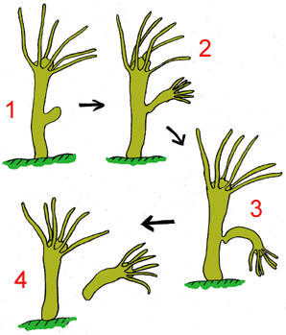 | 
Method:  Description: | Method:  Description:
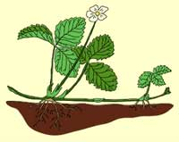 | 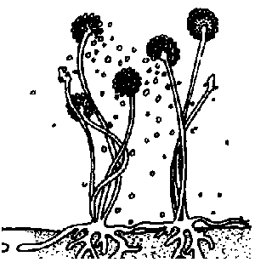
Method:  Description: | Method:  Description:
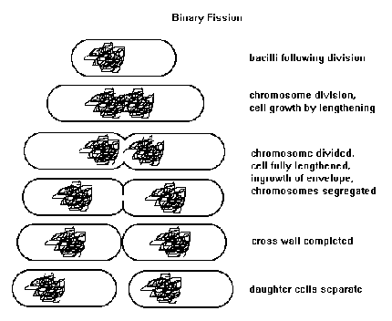 | Method:  Description:

Goal • Review your understanding of mitosis and meiosis.

Match each of the following descriptions with the corresponding event depicted in the diagram below. Write the correct letter in each blank.

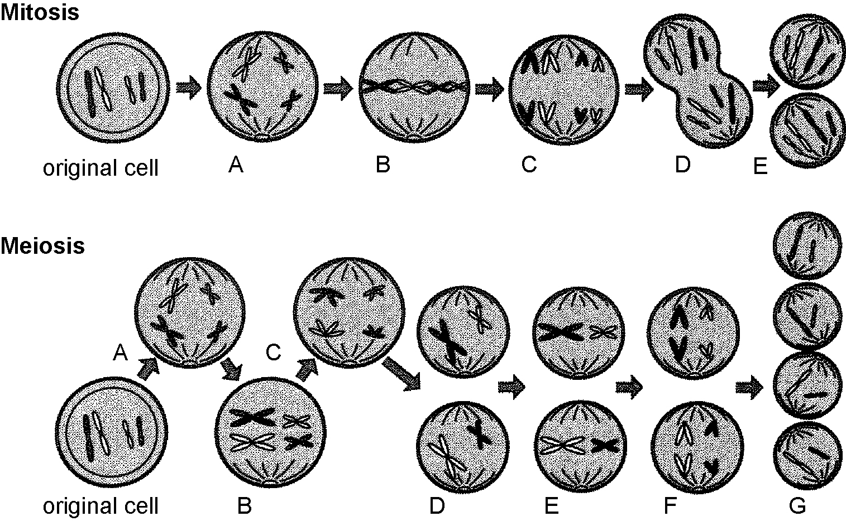

_________ 1. Chromatids are still joined in meiosis, but not in mitosis.
_________ 2. Chromatids separate.
_________ 3. Chromosomes double in both mitosis and meiosis.
_________ 4. Mitosis is complete, but another division is about to take place in meiosis.
The chromosomes line up along the centre of the cell.
_________ 5. In meiosis, the chromosomes separate but chromatids remain joined. In mitosis,
chromatids separate.
_________ 6. Chromosomes line up in pairs in meiosis but not in mitosis.
_________ 7. End products of meiosis

8. Use “haploid” and “diploid” to compare the end products of meiosis with the end
products of mitosis. How do they differ?
_____________________________________________________________________________
_____________________________________________________________________________

Read the statements given below. If the statement is true, write “T” on the line in front of the statement. If it is false, write “F” and rewrite the statement by changing the underlined word(s) to make it true.

____ 1. Gametes have twice as many chromosomes as other cells.
_________________________________________________________________________________

____ 2. Zygotes are produced by the union of sperm and egg cells.
_________________________________________________________________________________

____ 3. Meiosis may form egg cells.
_________________________________________________________________________________

____ 4. Gametes are formed during mitosis.
_________________________________________________________________________________

____ 5. Four new cells are formed from each parent cell in meiosis.
_________________________________________________________________________________

____ 6. There are two cell divisions during mitosis.
_________________________________________________________________________________

____ 7. Haploid refers to the gametes of a cell with only one set of chromosomes.
_________________________________________________________________________________

____ 8. If a cell with six chromosomes undergoes mitosis, each new cell will also have six
chromosomes.
______________________________________________________________________________

